**PHYSICAL EDUCATION – LESSON #5**

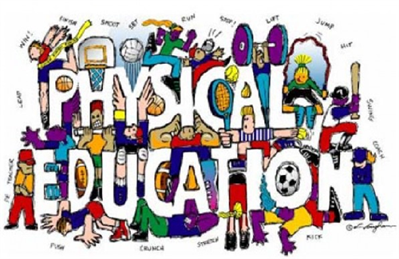

Hi Everyone,

Hope you are doing well! We really miss you! 🙁 Please try to the do Physical Education Lessons and **HAVE FUN!!!**

This week we are going to visit a website and choose 3 videos to participate in. The website that we will be visiting is YouTube. Go to [www.youtube.com](http://www.youtube.com) . Just search **Go Noodle** in the search bar. Please ask your family to help you if need it! 😊

Please complete the following videos listed below.

* “Milk Shake” 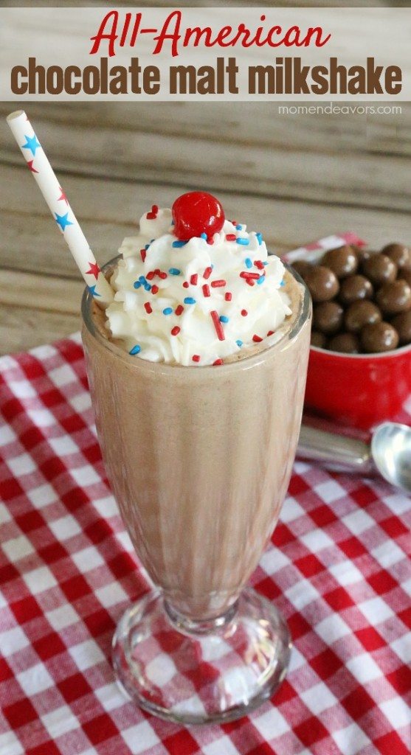
* “ Pop See Ko”



* “Boom Chicka Boom”

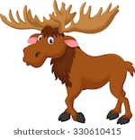

* “Cat Party”

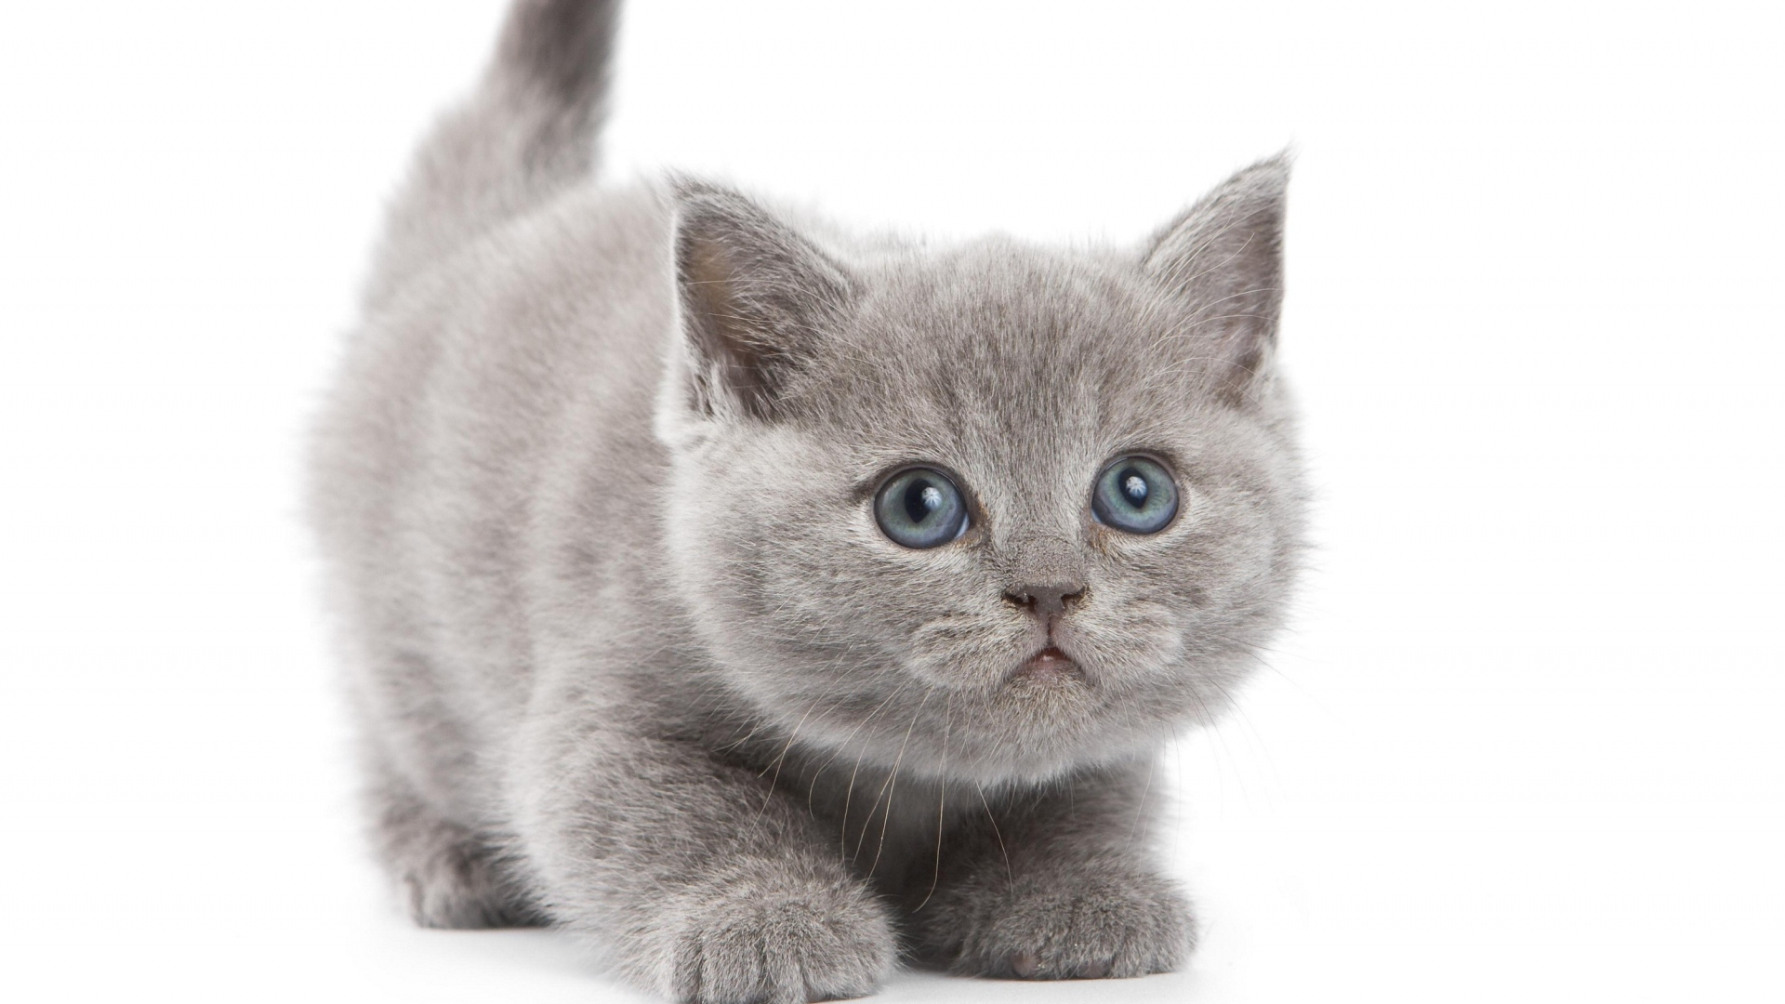

* “Trolls Can’t Stop the Feeling”

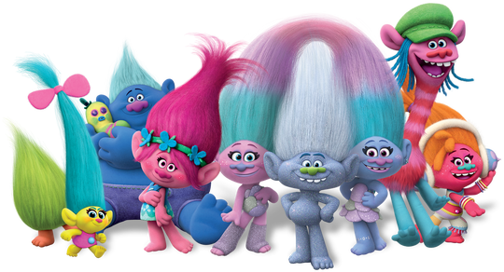

**HAVE FUN!**

**\*\*\*PLEASE COMPLETE 3 MORE VIDEOS FROM GONOODLE DURING THE REST OF THE WEEK!!!**

**\*\*\*Families just email Mrs. Miller at** [**MillerA@dvsd.org**](mailto:MillerA@dvsd.org) **or Mr. Feiss at** [**FeissJ@dvsd.org**](mailto:FeissJ@dvsd.org) **once the assignment is completed for credit! We would love to know another dance that you were able to do! You can also complete the dances from above again!!!**

**Mrs. Miller and Mr. Feiss 😊**